**Assignment - Level - 1**

**GitHub**

**Assignment -1**

Created a finalway_website as a dummy project and cloned Tic-Tac-Toe.

**-git config**

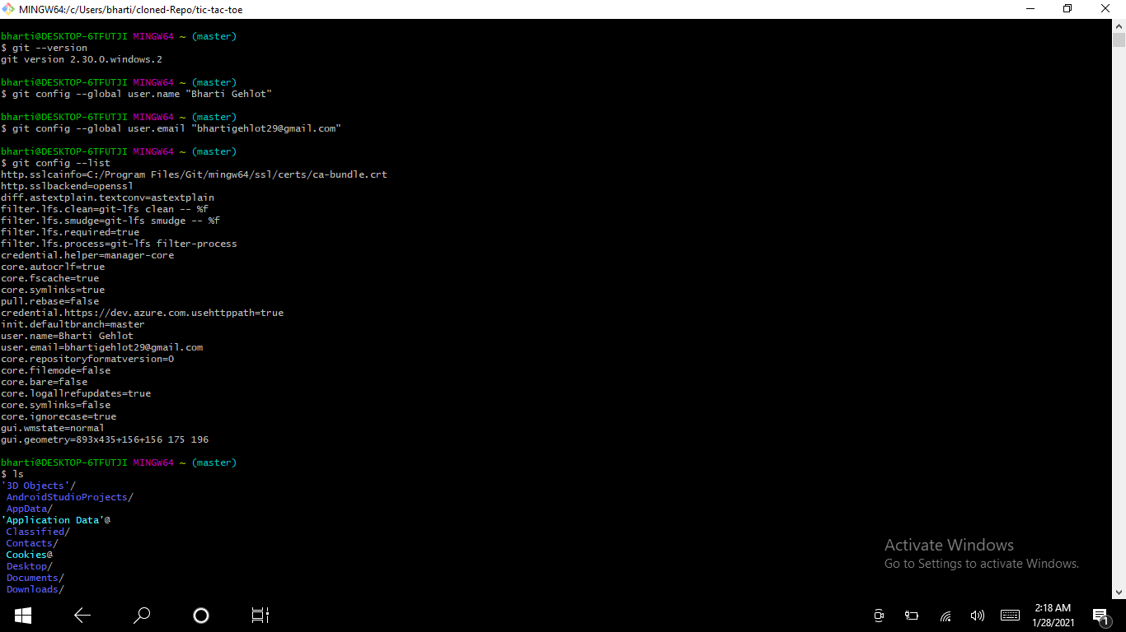

**-git init**

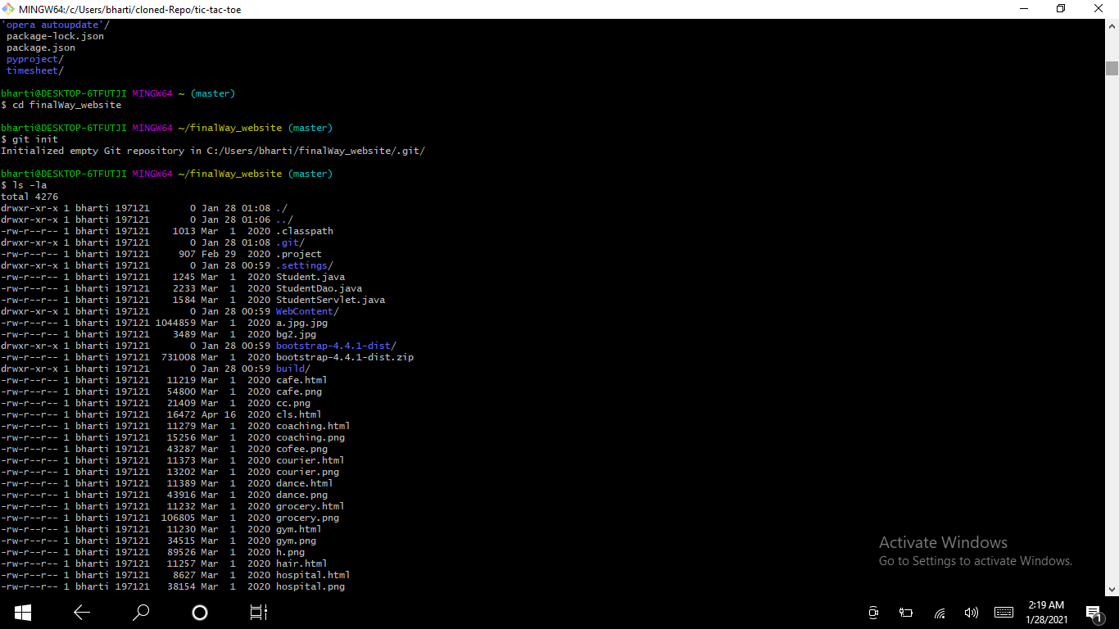

**- git status**

**- git add**

**- git reset**

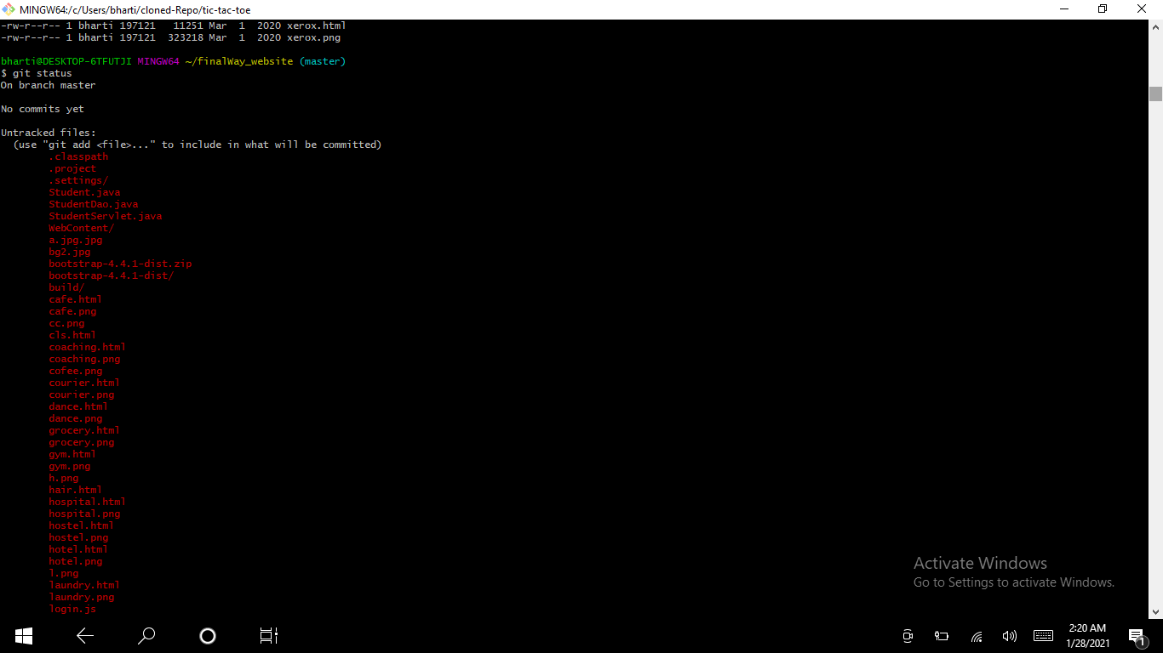

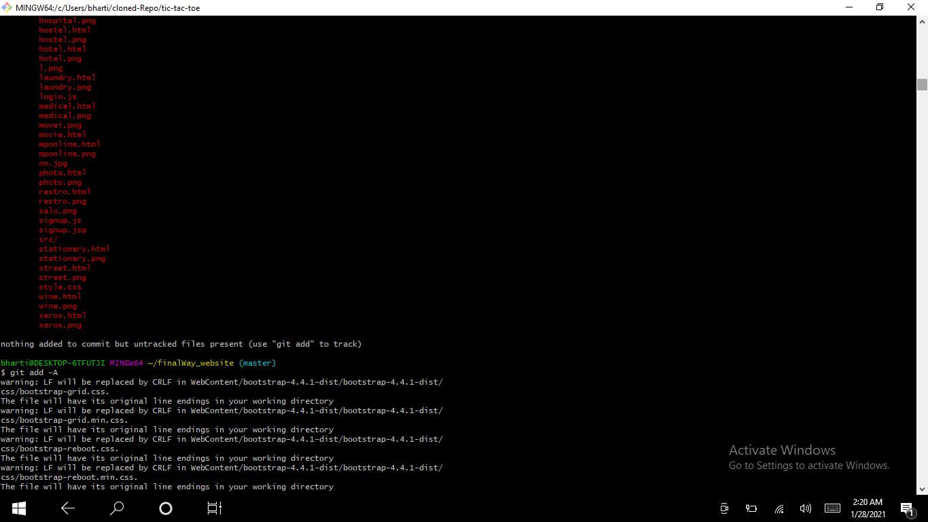

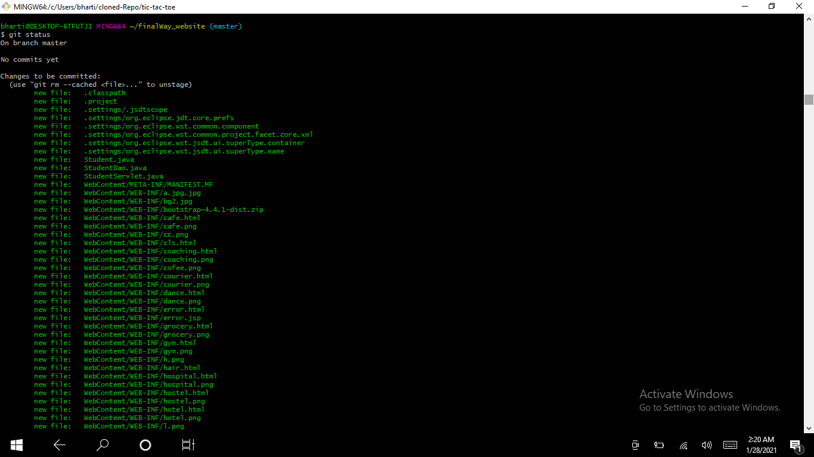

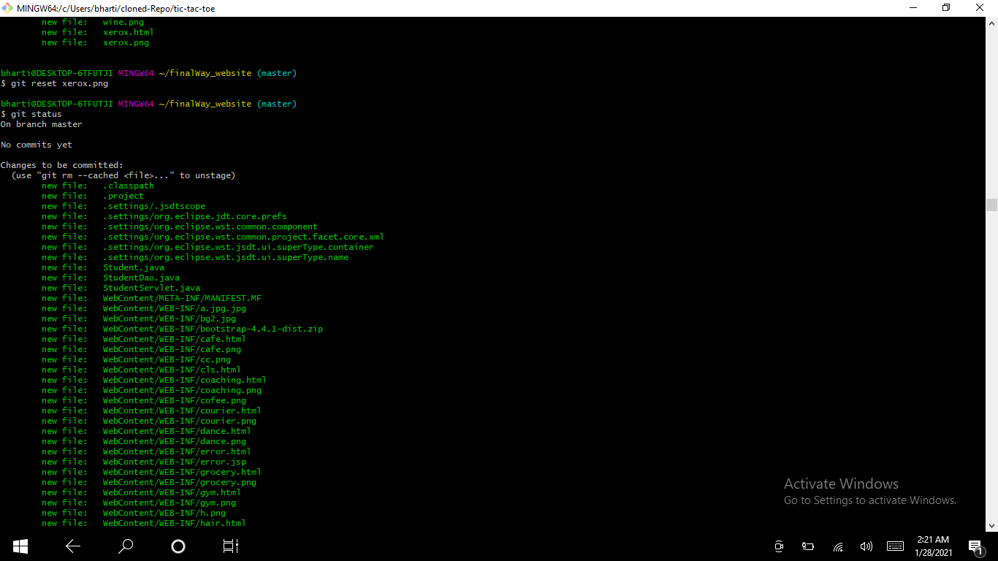

**-git commit**

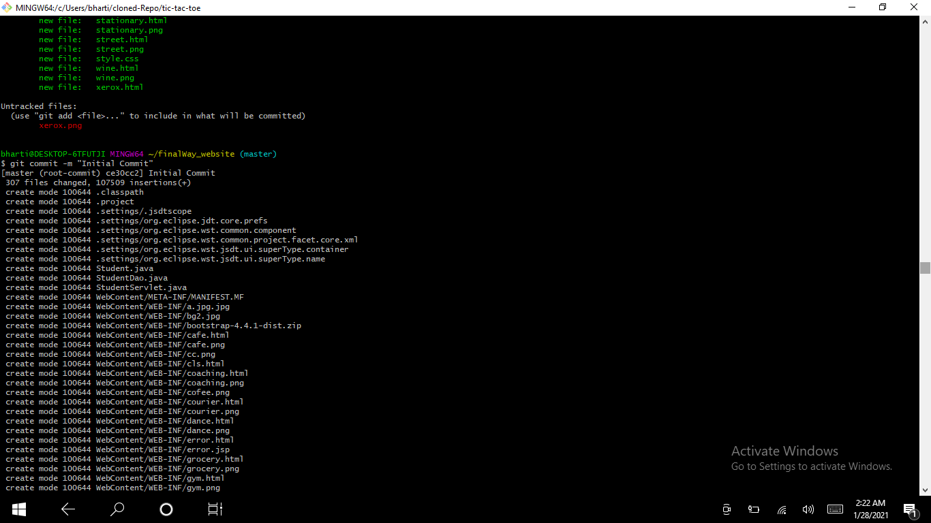

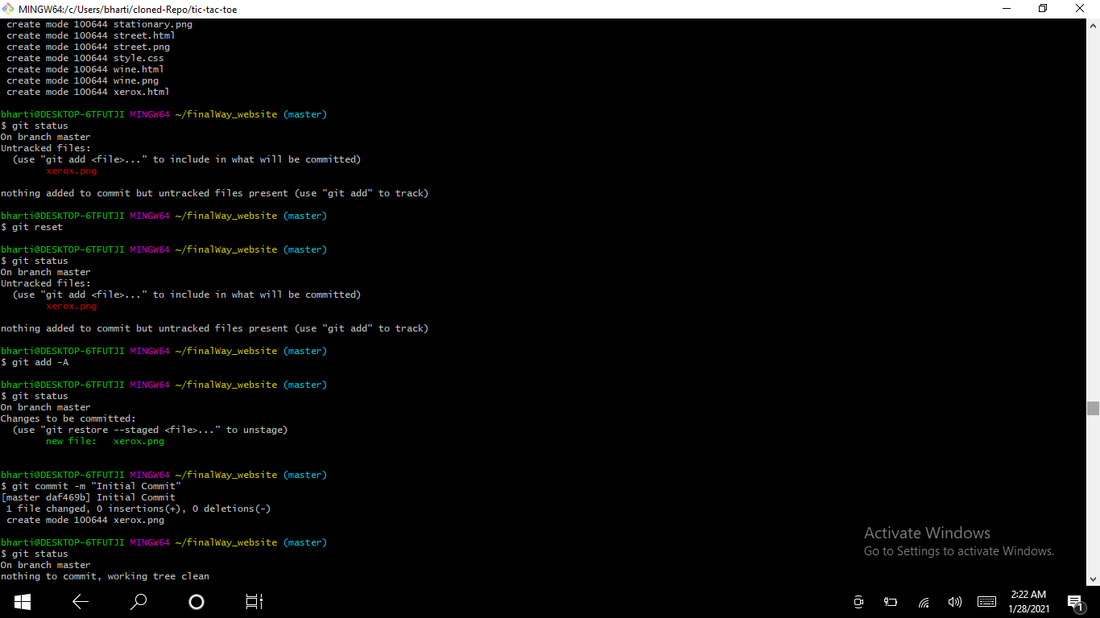

**- git log**

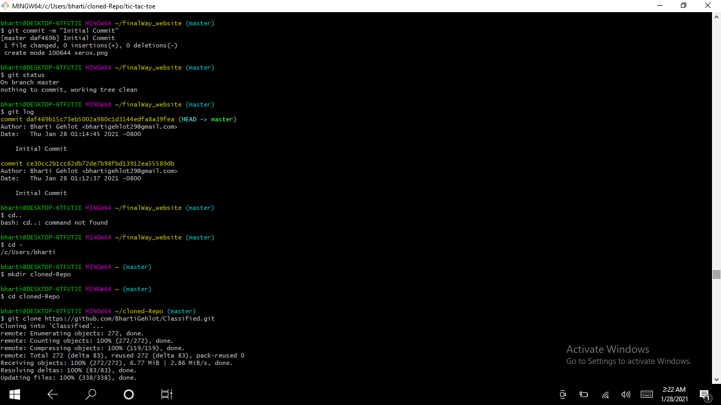

**- git clone**

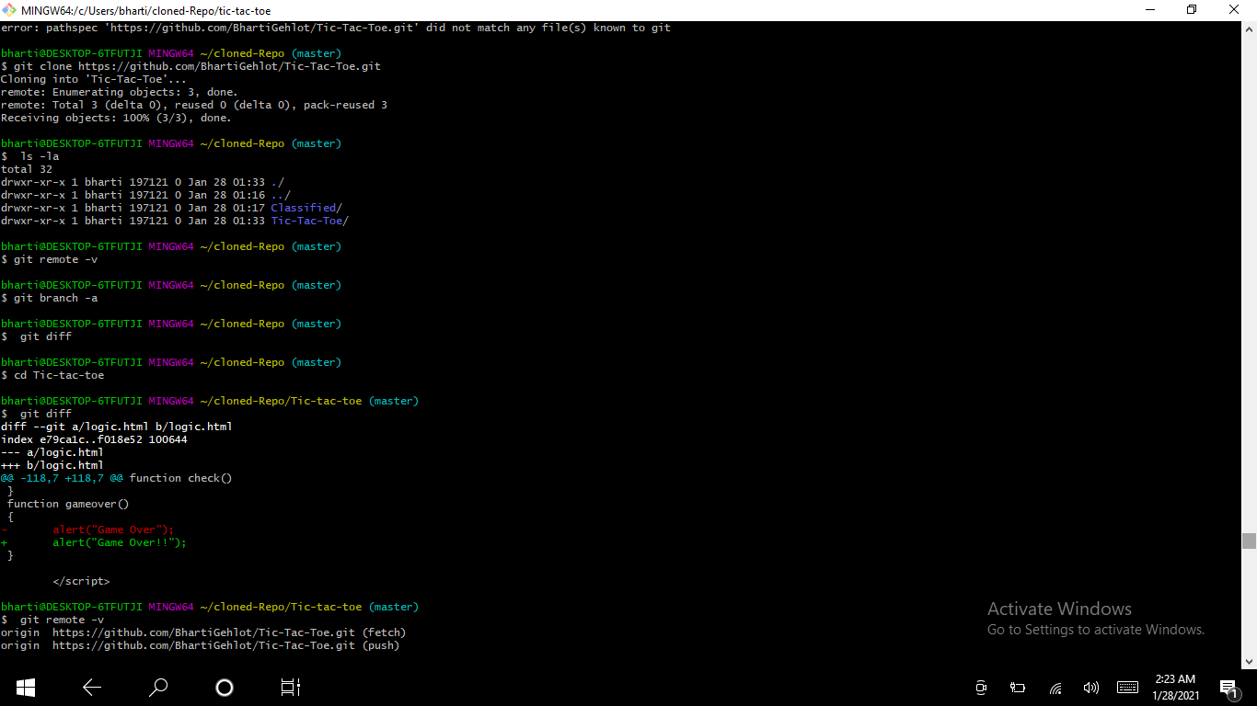

**- git remote**

**- git branch**

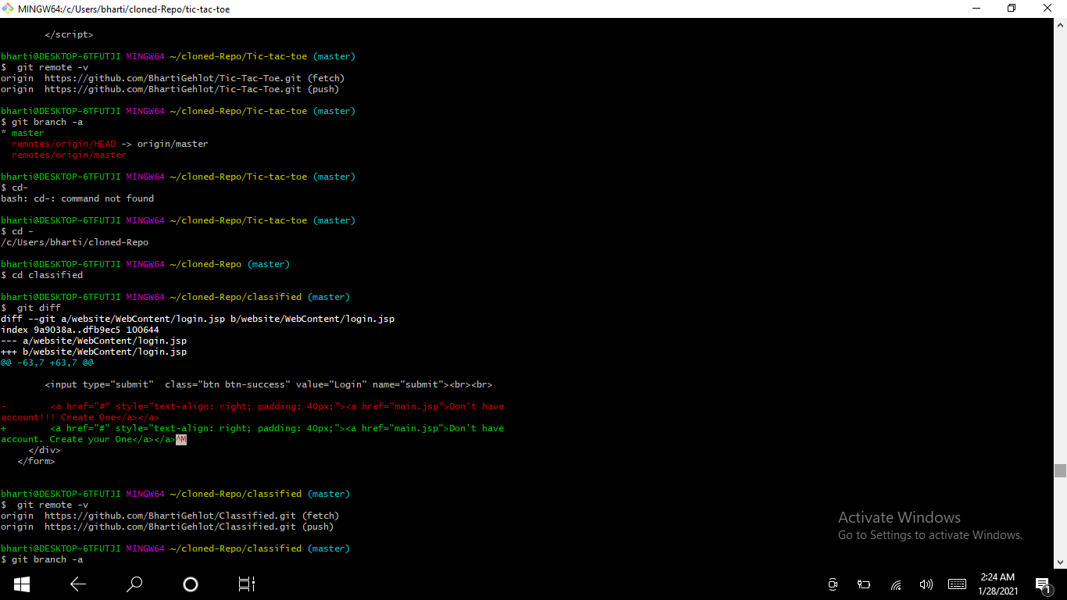

**- git diff**



**- git pull**

**- git push**

**- git checkout**

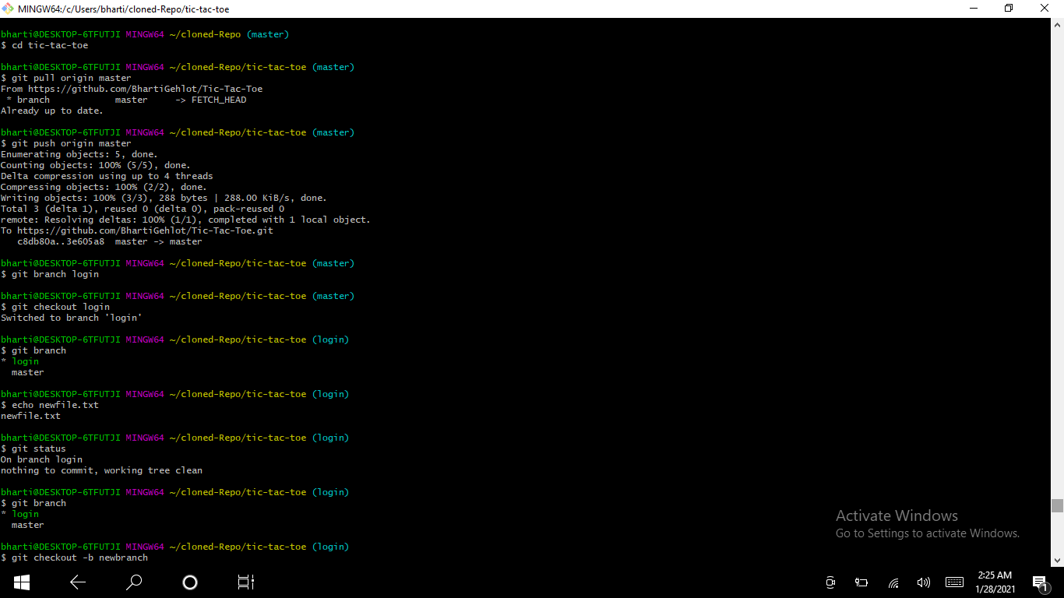

**- git merge**

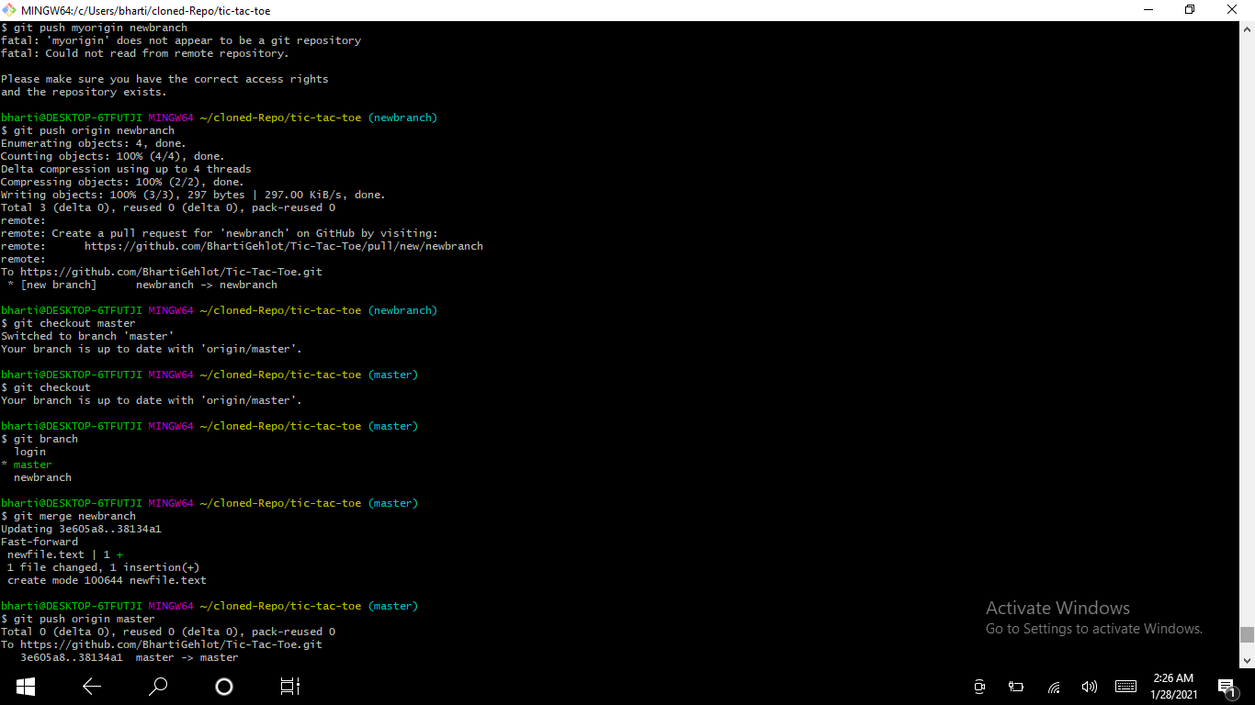

**Assignment-2**

**1.Give 3 reasons this team will benefit from using Git instead of google drive for**

**managing the codebase.**

**Ans =** Some of the reasons the teams will benefit from git instead of google drive are :

1. Performance :

Git provides the best performance when it comes to version control systems. Committing, branching, merging all are optimized for a better performance than other systems.

2. Security :

Git handles security with cryptographic method SHA-1. The algorithm manages versions, files, and directory securely so that team work is not corrupted.

3. Open source:

Being open source invites the developers from all over the world to contribute to the software and make it more and more powerful through features and additional plugins.

1. **Which 3 features of Git should this team learn to be successful?**

**Ans =** There are various features of Git which team should learn to be successful some of them are:

1. Cloning and managing remotes in git
2. Synchronize changes with the remote
3. Branching in git
4. Merging and forking

**3.What are 3 common mistakes people make when using Git in a team?**

Ans = Some of the common mistakes are:

1.Commitment of wrong data

2.Pushing a wrong branch to the remote

3.Replacing the latest commit with a new commit

4. Premature merges